

# Practices for Secure Software Report

Table of Contents

Document Revision History 3

Client 3

Instructions 3

Developer 4

1. Algorithm Cipher 4

2. Certificate Generation 4

3. Deploy Cipher 4

4. Secure Communications 4

5. Secondary Testing 4

6. Functional Testing 4

7. Summary 4

8. Industry Standard Best Practices 4

## Document Revision History

| **Version** | **Date** | **Author** | **Comments** |
| --- | --- | --- | --- |
| **1.0** | **[Date]** | **[Your Name]** |  |

## Client



## Instructions

Submit this completed practices for secure software report. Replace the bracketed text with the relevant information. You must document your process for writing secure communications and refactoring code that complies with software security testing protocols.

* Respond to the steps outlined below and include your findings.
* Respond using your own words. You may also choose to include images or supporting materials. If you include them, make certain to insert them in all the relevant locations in the document.
* Refer to the Project Two Guidelines and Rubric for more detailed instructions about each section of the template.

## Developer

Atsushi Ogata

## Algorithm Cipher

The algorithm ciphers I would recommend for the project are SHA-256 and AES-256. SHA-256 is a hashing algorithm that functions by encrypting messages into fixed-length encryptions called message digests. SHA-256 is considered to be one of the most secure hashing algorithms due to its resistance to collision attacks. SHA-256 produces a 256-bit hash value, which is represented as a 64-character hex string. This large bit size makes it highly secure against reverse engineering and collision attacks. The original SHA algorithm, SHA-1, is considered obsolete due to its weakness in collision attacks. This issue stems largely from its limited key size. This issue is resolved with SHA-256, and it remains one of the most secure hashing algorithms today, leading to its wide adoption in data security applications (Harish, n.d.).

AES is a symmetric encryption algorithm, meaning the same key is used for both encryption and decryption. AES provides robust protection against various cryptographic attacks, including brute-force attacks, by using multiple transformation steps during the encryption process. The security of AES is further enhanced when longer keys, such as the 256-bit key in AES-256, are used. This significantly increases the protection against brute-force attacks (Portnox, n.d.). AES was selected by the National Institute of Standards and Technology in 2001 to replace the aging Data Encryption Standard (DES), which was growing increasingly vulnerable to brute-force attacks due to its small key size. AES-256, with its 256-bit key, has now become the gold standard for encryption and is widely used in industries that require high security, such as finance, healthcare, and government (Beckett, 2023).

In encryption, random numbers are used to generate initialization vectors (IVs). An IV ensures the same plaintext encrypted with the same key produces different ciphertexts, thereby enhancing security by preventing patterns in the encrypted data (Awati, 2022). AES, as mentioned above, is a symmetric encryption algorithm that uses the same key for encryption and decryption. Symmetric encryption is faster and more efficient for encrypting large amounts of data. On the other hand, asymmetric encryption uses a pair of keys. A public key is used for encryption and a private key for decryption. A notable use case of asymmetric encryption is in the TLS/SSL protocol, where a secure client-server session is established asymmetrically (Daniel, 2021).

## Certificate Generation

Insert a screenshot below of the CER file.

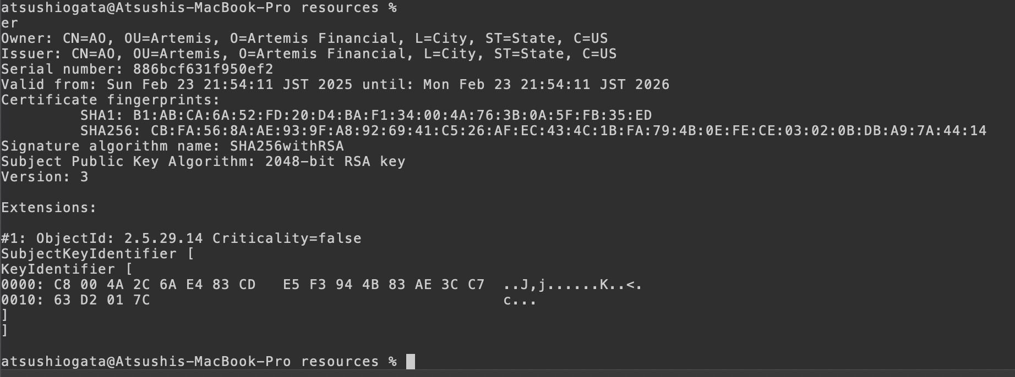

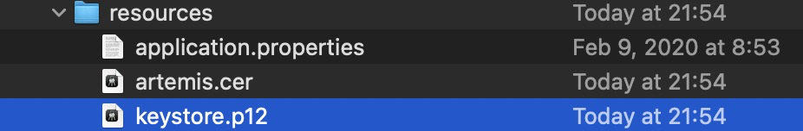

## Deploy Cipher

Insert a screenshot below of the checksum verification.

[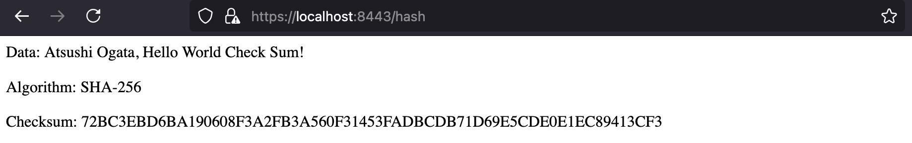

## Secure Communications

## Due to the certificate being self-signed, the browser marked it as a risk. However, the code was refactored to accommodate HTTPS.

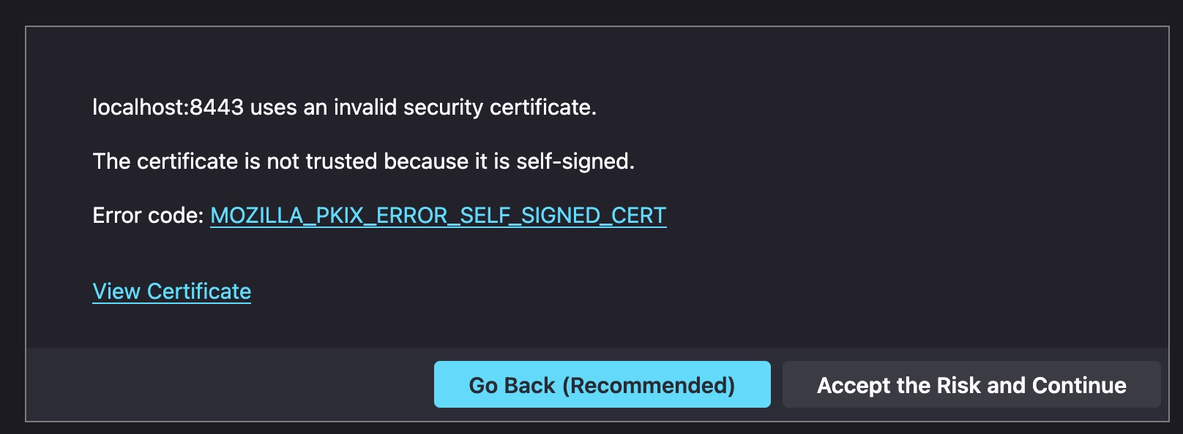

## Secondary Testing

Insert screenshots below of the refactored code executed without errors and the dependency-check report.

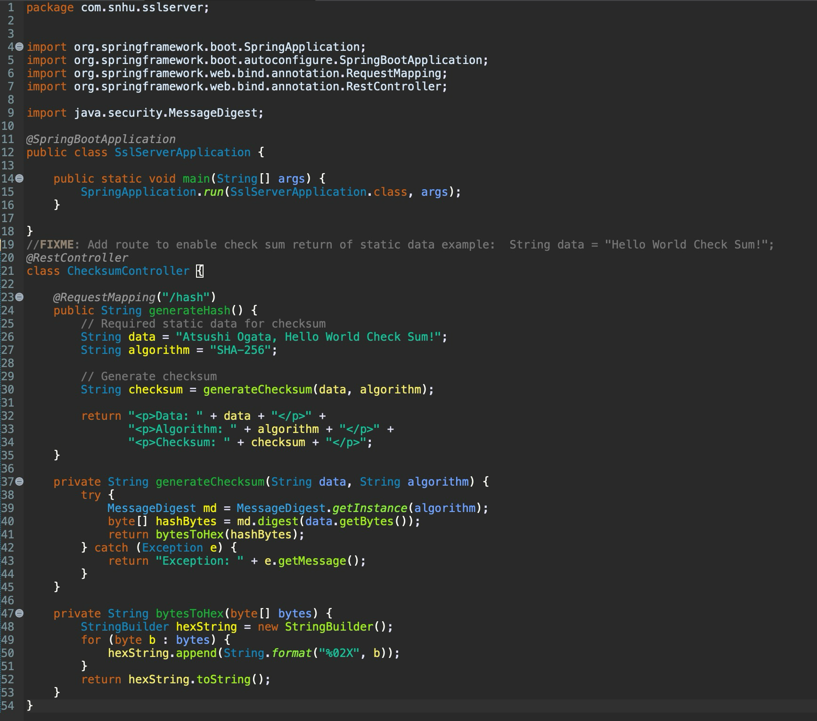

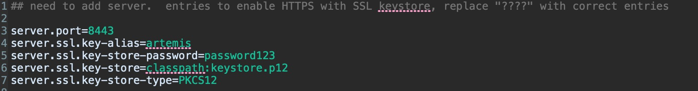

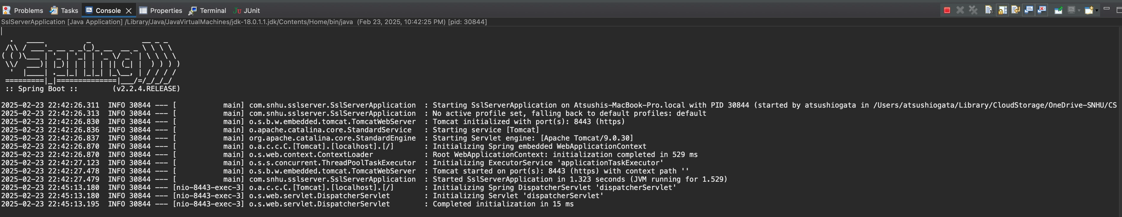

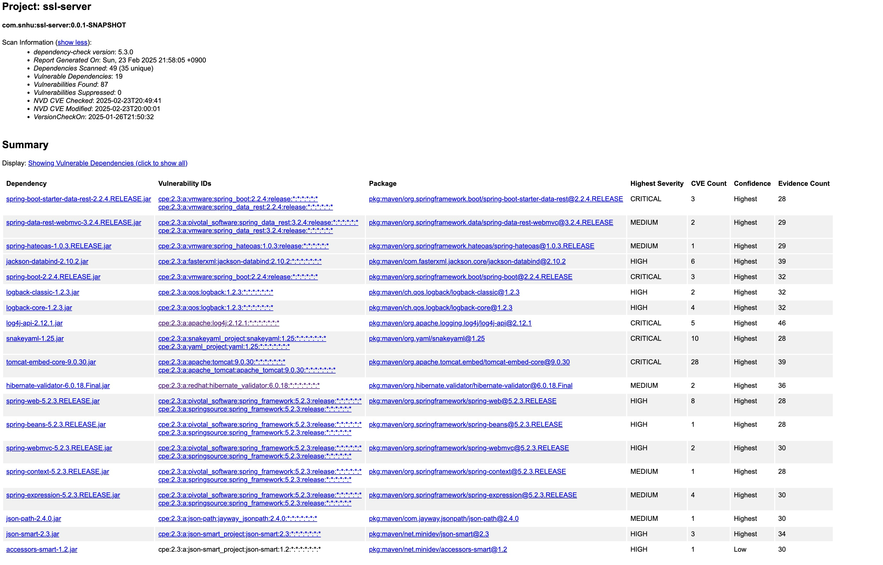

## Functional Testing

Insert a screenshot below of the refactored code executed without errors.







## Summary

The refactored code addresses the following key security areas from the Vulnerability Assessment Process Flow Diagram:

* Architecture review
  + The application’s architecture was updated to enforce HTTPS communication by configuring the server.ssl properties in the application properties file
* APIs
  + The RESTful endpoint /hash was implemented using Spring Boot’s Rest controller, adhering to best practices for secure API interactions
  + The response only includes essential data, thus reducing the risk of exposing sensitive information
* Cryptography
  + The SHA-256 hashing algorithm was implemented in ChecksmController to generate a cryptographic checksum to ensure data integrity
  + The Java MessageDigest API was used securely, avoiding outdated algorithms like SHA-1
* Client/Server Security
  + HTTPS was enabled by creating a self-signed SSL certificate using Java Keytool and configuring the keystore
* Code Error and Quality
  + The code was refactored for readability and maintainability
  + Exception handling was implemented in the hashing method generateChecksum to handle cryptographic errors
* Encapsulation
  + Data structures were encapsulated by using private methods for the checksum generation and byte-to-hex conversion
* Static Testing and Code Review
  + The OWASP Dependency-Check tool was used to scan dependencies for security vulnerabilities
  + The output was reviewed to ensure that no new vulnerabilities were introduced
  + The code was manually reviewed for secure coding patterns

These changes address multiple layers of security, including secure communication, cryptographic best practices, and vulnerability testing.

## Industry Standard Best Practices

Several industry-standard best practices were applied in the refactored code. For example, secure communications were enforced by utilizing HTTPS and SSL/TLS. Keystore and certificate management was carried out to ensure the connection remains secure. The SHA-256 algorithm also introduced strong cryptographic hashing that is secure and collision-resistant. Further, sensitive information, such as the Keystore password, was not hardcoded in the application code. Instead, these were stored in the application.properties file. Further, static code analysis was carried out. The OWASP Dependency-Check tool was used to scan for vulnerabilities in dependencies. Applying industry standard best practices like these for secure coding contributes to Artemis Financials’ overall well-being since it reduces security risks like data breaches and exploits. Secure coding practices also help the company maintain regulatory compliance. Further, these practices help protect sensitive user data, thereby fostering stakeholder trust.

**References:**

Awati, R. (2022). *Initialization vector*. TechTarget. <https://www.techtarget.com/whatis/definition/initialization-vector-IV>

Beckett, S. (November 1, 2023). *The Evolution of AES*. GhostVolt. https://ghostvolt.com/blog/the-history-of-aes-encryption.html

Daniel, B. (May 4, 2021). *Symmetric vs. Asymmetric Encryption: What's the Difference?*. Trenton Systems. https://www.trentonsystems.com/en-us/resource-hub/blog/symmetric-vs-asymmetric-encryption

Harish, A. (n.d.). *SHA-256 vs. SHA-1: Which Is The Better Encryption?* secureW2. <https://www.securew2.com/blog/what-is-sha-encryption-sha-256-vs-sha-1#:~:text=Regarding%20SHA%2D1%20and%20SHA,of%20security%20for%20SHA%2D256>.

Portnox. (n.d). *What is Advanced Encryption Standard (AES)?* [*https://www.portnox.com/cybersecurity-101/what-is-advanced-encryption-standard-aes/*](https://www.portnox.com/cybersecurity-101/what-is-advanced-encryption-standard-aes/)